1.6 Microeconomics: Zeroing in on Businesses and Consumers
- What are the basic microeconomic concepts of demand and supply, and how do they establish prices?
Now let’s shift our focus from the whole economy to microeconomics, the study of households, businesses, and industries. This field of economics is concerned with how prices and quantities of goods and services behave in a free market. It stands to reason that people, firms, and governments try to get the most from their limited resources. Consumers want to buy the best quality at the lowest price. Businesses want to keep costs down and revenues high to earn larger profits. Governments also want to use their revenues to provide the most effective public goods and services possible. These groups choose among alternatives by focusing on the prices of goods and services.
As consumers in a free market, we influence what is produced. If Mexican food is popular, the high demand attracts entrepreneurs who open more Mexican restaurants. They want to compete for our dollars by supplying Mexican food at a lower price, of better quality, or with different features, such as Santa Fe Mexican food rather than Tex-Mex. This section explains how business and consumer choices influence the price and availability of goods and services.

Exhibit 1.10 Galaxy Note 7 Samsung’s strategy to take on Apple’s iPhone domination hit a terrible snag in 2016, when its Galaxy Note 7 mobile phone was recalled and the product eliminated. Defective batteries in the Note 7 made them catch fire and cause serious damage. Samsung eventually killed the entire line of Note 7 phones, recalling nearly 3 million phones, which cost the company more than $5 billion. How do businesses determine the optimum quantity of products or services to make available to consumers? (Credit: Paul Sullivan/ flickr/ Attribution-NoDerivs 2.0 Generic (CC BY-ND 2.0))

The Nature of Demand
Demand is the quantity of a good or service that people are willing to buy at various prices. The higher the price, the lower the quantity demanded, and vice versa. A graph of this relationship is called a demand curve.
Let’s assume you own a store that sells jackets for snowboarders. From past experience, you know how many jackets you can sell at different prices. The demand curve in Exhibit 1.11 depicts this information. The x-axis (horizontal axis) shows the quantity of jackets, and the y-axis (vertical axis) shows the related price of those jackets. For example, at a price of $100, customers will buy (demand) 600 snowboard jackets.
In the graph, the demand curve slopes downward and to the right because as the price falls, people will want to buy more jackets. Some people who were not going to buy a jacket will purchase one at the lower price. Also, some snowboarders who already have a jacket will buy a second one. The graph also shows that if you put a large number of jackets on the market, you will have to reduce the price to sell all of them.
Understanding demand is critical to businesses. Demand tells you how much you can sell and at what price—in other words, how much money the firm will take in that can be used to cover costs and hopefully earn a profit. Gauging demand is difficult even for the very largest corporations, but particularly for small firms.
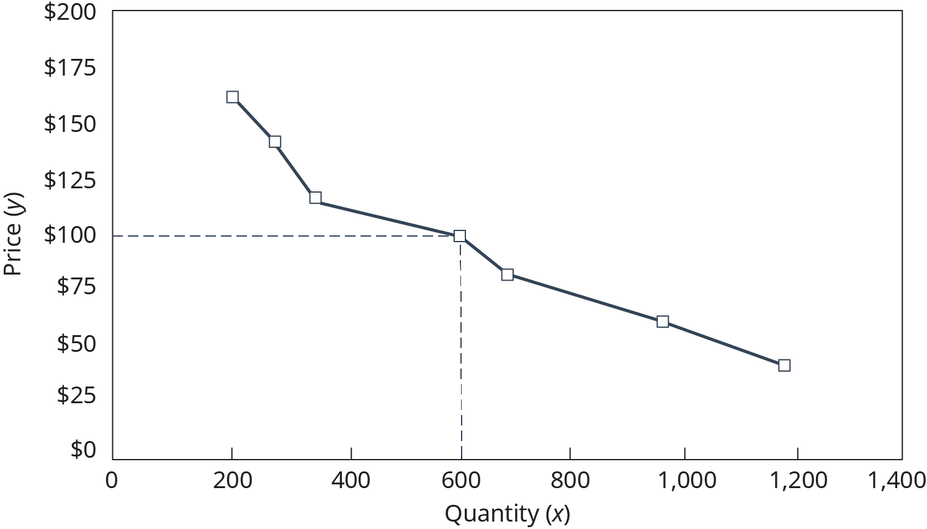
Exhibit 1.11 Demand Curve for Jackets for Snowboarders (Attribution: Copyright Rice University, OpenStax, under CC-BY 4.0 license)

The Nature of Supply
Demand alone is not enough to explain how the market sets prices. We must also look at supply, the quantity of a good or service that businesses will make available at various prices. The higher the price, the greater the number of jackets a supplier will supply, and vice versa. A graph of the relationship between various prices and the quantities a business will supply is a supply curve.
We can again plot the quantity of jackets on the x-axis and the price on the y-axis. As Exhibit 1.12 shows, 800 jackets will be available at a price of $100. Note that the supply curve slopes upward and to the right, the opposite of the demand curve. If snowboarders are willing to pay higher prices, suppliers of jackets will buy more inputs (for example, Gore-Tex® fabric, dye, machinery, labor) and produce more jackets. The quantity supplied will be higher at higher prices, because manufacturers can earn higher profits.
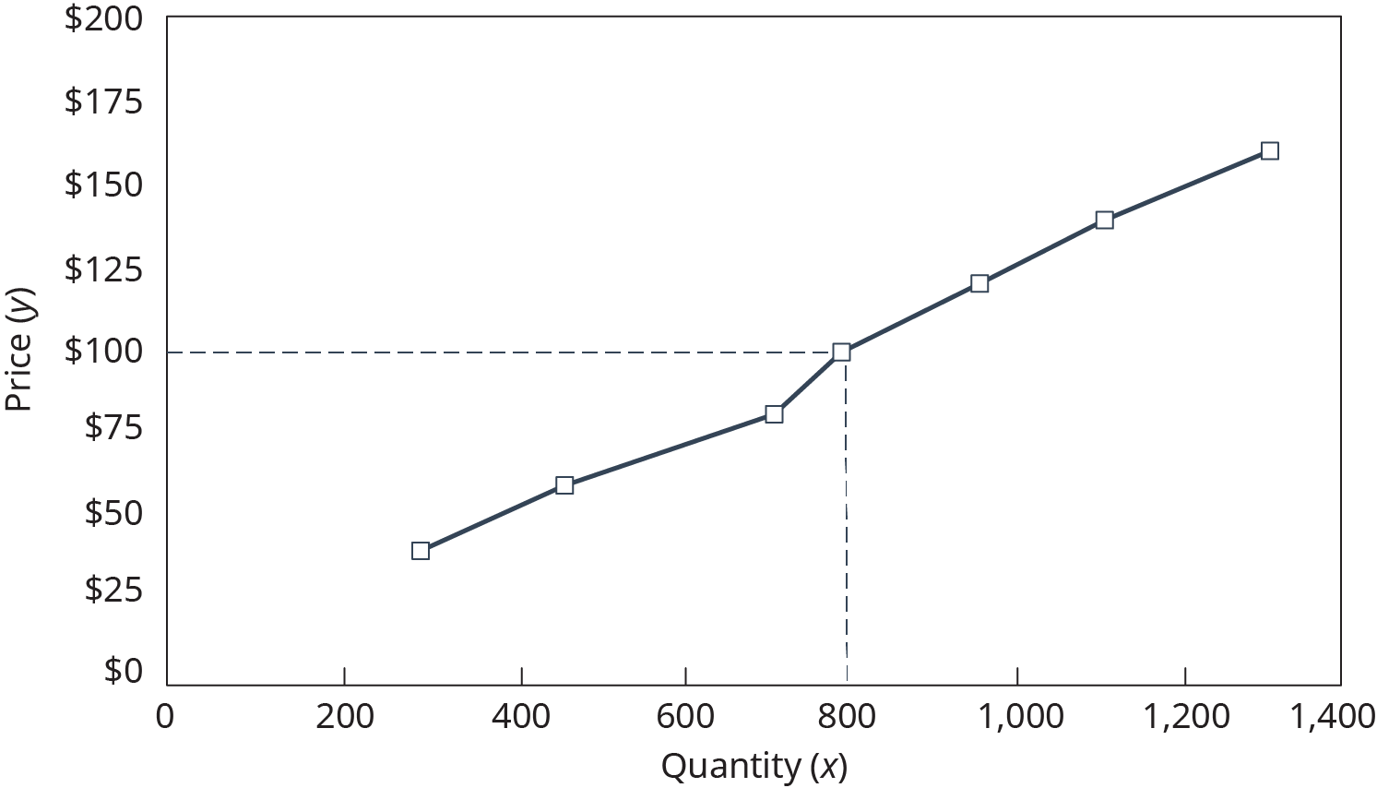
Exhibit 1.12 Supply Curve for Jackets for Snowboarders (Attribution: Copyright Rice University, OpenStax, under CC-BY 4.0 license)

How Demand and Supply Interact to Determine Prices
In a stable economy, the number of jackets that snowboarders demand depends on the jackets’ price. Likewise, the number of jackets that suppliers provide depends on price. But at what price will consumer demand for jackets match the quantity suppliers will produce?
To answer this question, we need to look at what happens when demand and supply interact. By plotting both the demand curve and the supply curve on the same graph in Exhibit 1.13, we see that they cross at a certain quantity and price. At that point, labeled E, the quantity demanded equals the quantity supplied. This is the point of equilibrium. The equilibrium price is $80; the equilibrium quantity is 700 jackets. At that point, there is a balance between the quantity consumers will buy and the quantity suppliers will make available.
Market equilibrium is achieved through a series of quantity and price adjustments that occur automatically. If the price increases to $160, suppliers produce more jackets than consumers are willing to buy, and a surplus results. To sell more jackets, prices will have to fall. Thus, a surplus pushes prices downward until equilibrium is reached. When the price falls to $60, the quantity of jackets demanded rises above the available supply. The resulting shortage forces prices upward until equilibrium is reached at $80.
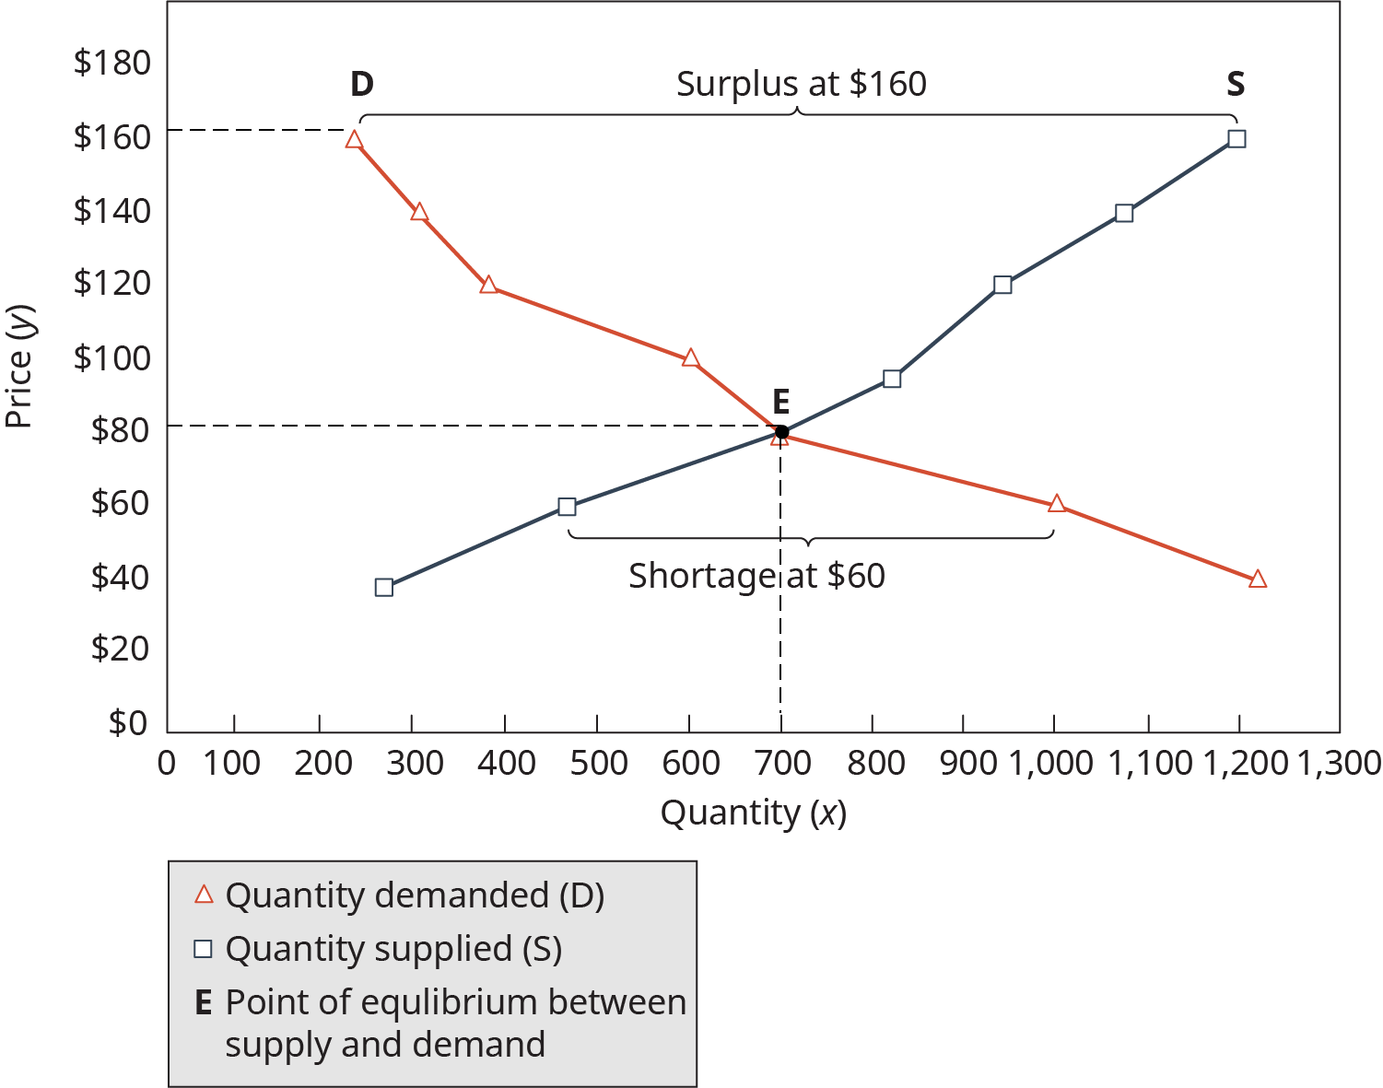
Exhibit 1.13 Equilibrium Price and Quantity for Jackets for Snowboarders (Attribution: Copyright Rice University, OpenStax, under CC-BY 4.0 license)
The number of snowboard jackets supplied and bought at $80 will tend to rest at equilibrium unless there is a shift in either demand or supply. If demand increases, more jackets will be purchased at every price, and the demand curve shifts to the right (as illustrated by line D₂ in Exhibit 1.14). If demand decreases, less will be bought at every price, and the demand curve shifts to the left (D₁). When demand decreased, snowboarders bought 500 jackets at $80 instead of 700 jackets. When demand increased, they purchased 800.

Changes in Demand
A number of things can increase or decrease demand. For example, if snowboarders’ incomes go up, they may decide to buy a second jacket. If incomes fall, a snowboarder who was planning to purchase a jacket may wear an old one instead. Changes in fashion or tastes can also influence demand. If snowboarding were suddenly to go out of fashion, demand for jackets would decrease quickly. A change in the price of related products can also influence demand. For example, if the average price of a snowboard rises to $1,000, people will quit snowboarding, and jacket demand will fall.
Another factor that can shift demand is expectations about future prices. If you expect jacket prices to increase significantly in the future, you may decide to go ahead and get one today. If you think prices will fall, you will postpone your purchase. Finally, changes in the number of buyers will affect demand. Snowboarding is a young person’s sport, and the number of teenagers will increase in the next few years. Therefore, the demand for snowboard jackets should increase.
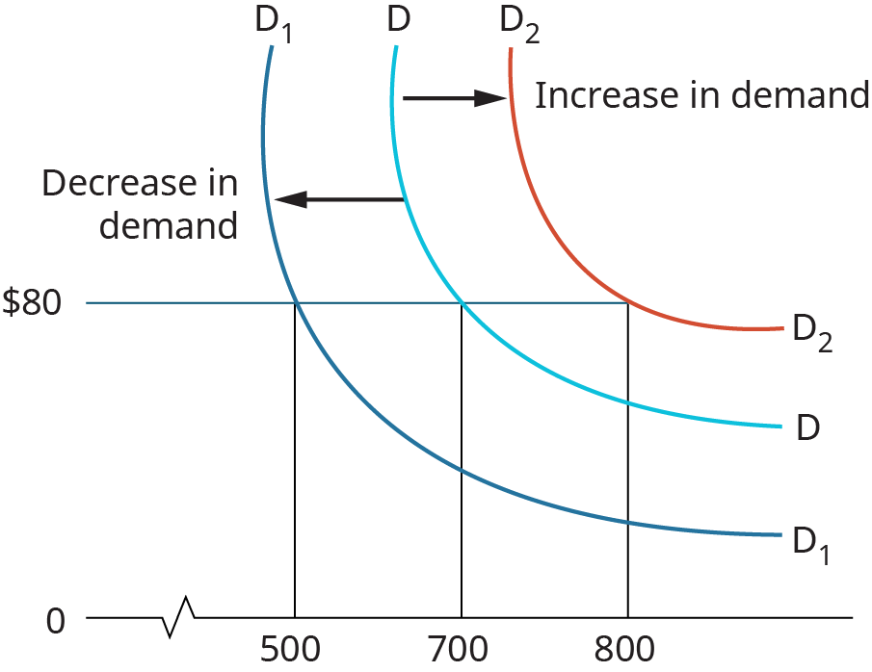
Exhibit 1.14 Shifts in Demand for Jackets for Snowboarders (Attribution: Copyright Rice University, OpenStax, under CC-BY 4.0 license)

Changes in Supply
Other factors influence the supply side of the picture. New technology typically lowers the cost of production. For example, North Face, a supplier of ski and snowboard jackets, purchased laser-guided pattern-cutting equipment and computer-aided pattern-making equipment. Each jacket was cheaper to produce, resulting in a higher profit per jacket. This provided an incentive to supply more jackets at every price. If the price of resources such as labor or fabric goes up, North Face will earn a smaller profit on each jacket, and the amount supplied will decrease at every price. The reverse is also true. Changes in the prices of other goods can also affect supply.
Let’s say that snow skiing becomes a really hot sport again. The number of skiers jumps dramatically, and the price of ski jackets soars. North Face can use its machines and fabrics to produce either ski or snowboard jackets. If the company can make more profit from ski jackets, it will produce fewer snowboard jackets at every price. Also, a change in the number of producers will shift the supply curve. If the number of jacket suppliers increases, they will place more jackets on the market at every price. If any suppliers stop making jackets available, the supply will naturally decrease. Taxes can also affect supply. If the government decides, for some reason, to tax the supplier for every snowboard jacket produced, then profits will fall, and fewer jackets will be offered at every price. Table 1.2 summarizes the factors that can shift demand and supply curves.
To better understand the relationship between supply and demand across the economy, consider the impact of 2005’s Hurricane Katrina on U.S. energy prices. Oil and gas prices were already at high levels before Hurricane Katrina disrupted production in the Gulf Coast. Most U.S. offshore drilling sites are located in the Gulf of Mexico, and almost 30 percent of U.S. refining capacity is in Gulf States that were hit hard by the storm. Prices rose almost immediately as supplies fell while demand remained at the same levels.
The storm drove home the vulnerability of the U.S. energy supply to not only natural disasters, but also terrorist attacks and price increases from foreign oil producers. Many energy policy experts questioned the wisdom of having such a high concentration of oil facilities—about 25 percent of the oil and natural gas infrastructure—in hurricane-prone states. Refiners were already almost at capacity before Katrina’s devastation.²⁷
Factors That Cause Demand and Supply Curves to Shift
 | Shift Demand
Factor | To the Right If | To the Left If
Buyers’ incomes | Increase | Decrease
Buyers’ preferences/tastes | Increase | Decrease
Prices of substitute products | Increase | Decrease
Expectations about future prices | Will rise | Will fall
Number of buyers | Increases | Decreases
 | Shift Supply
 | To the Right If | To the Left If
Technology | Lowers cost | Increases cost
Resource prices | Fall | Rise
Changes in prices of other products that can be produced with the same resources | Profit of other product falls | Profit of other product rises
Number of suppliers | Increases | Decreases
Taxes | Decreases | Increases
Table 1.2
High energy prices affect the economy in many ways. With oil at the time costing $50 to $60 a barrel—more than double the 2003 price—both businesses and consumers across the United States felt the pinch in their wallets. Midwestern agricultural businesses export about 70 percent of their grain production through Gulf of Mexico port facilities. With fewer usable docking spaces, barges couldn’t unload and return for more crops. The supply of both transportation services and grain products was inadequate to meet demand, pushing up transportation and grain costs. Higher gas prices also contributed to rising prices, as 80 percent of shipping costs are related to fuel.
More than a decade after Katrina, U.S. gas prices have fluctuated dramatically, with the cost of a gallon of regular gas peaking in 2014 at $3.71, dropping as low as $1.69 in early 2015, and moderating to $2.36 in mid-2017. Recent research by JP Morgan Chase revealed that consumers spend roughly 80 percent of their savings from lower gas prices, which helps the overall economy.²⁸

Concept Check
- What is the relationship between prices and demand for a product?
- How is market equilibrium achieved? Describe the circumstances under which the price for gasoline would have returned to equilibrium in the United States after Hurricane Katrina.
- Draw a graph that shows an equilibrium point for supply and demand.

